# PROJECT INFORMATION by Ritik

In this project of **predicting house price** we are facing many problems like an error in the data-set of houses and to solutions of errors, we are using many libraries to simplifying the huge dataset of houses.

LIBRARIES AND EDITORS

We use matplot library and graph lab (SFrame ) for huge data analysis and canvas for graph plotting.

We choose the ML model for this project because the project predicting house price has huge data sets of many types like sqft living, no.of bathroom, etc. ML is perfect for this project because we can easily use mathematics in ML for any problem’s solutions.

First, we import what we need to make the process easy. then we take the dataset and import in our ipynb we use the jupyter notebook. After this, we use the algorithm to predicting house prices we add some new features to our prediction code for the variability of our prediction project after this we can check our model via testing data of houses.

# ....CODE...

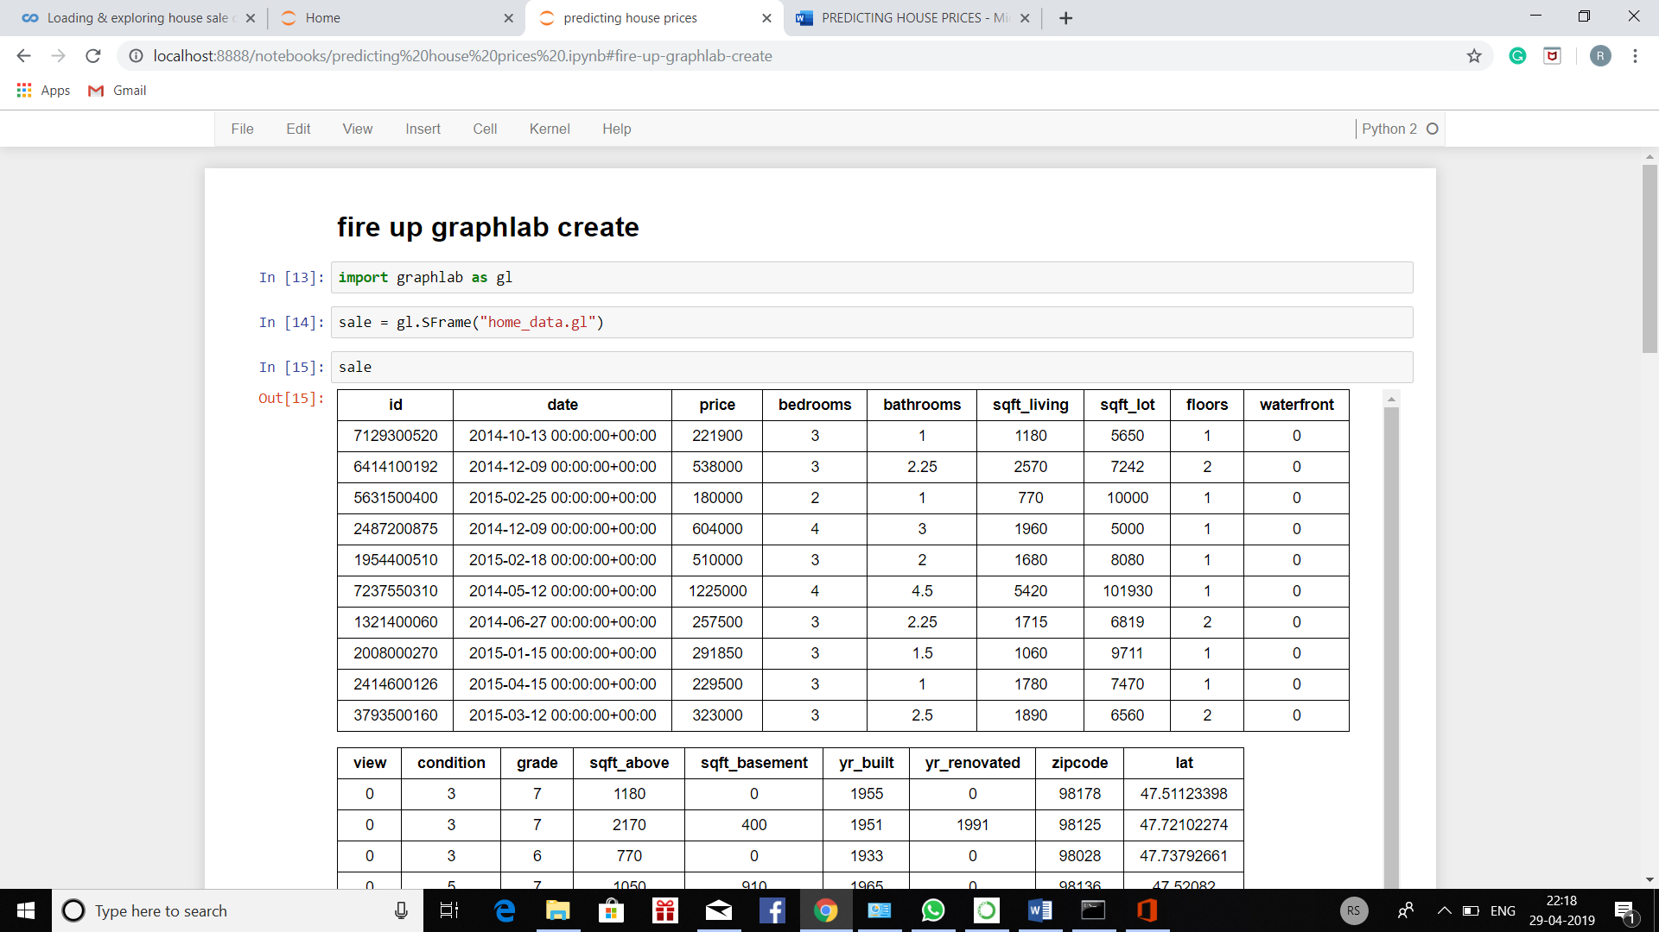

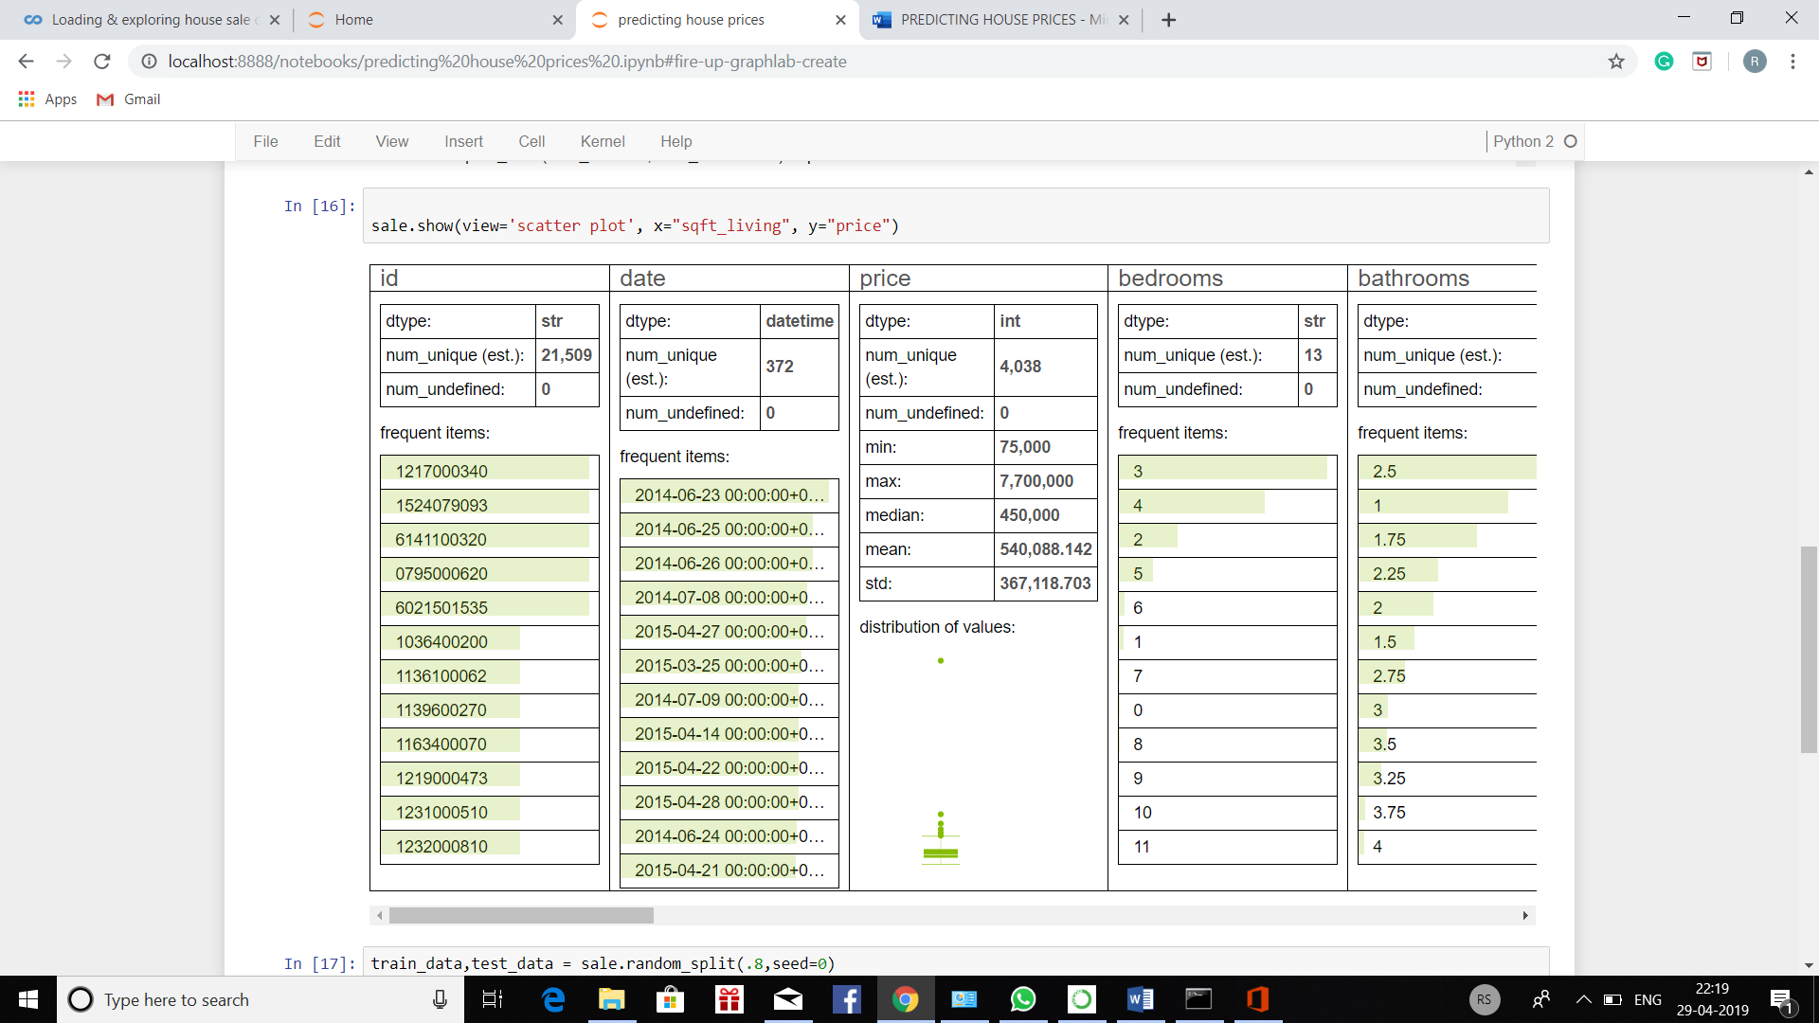

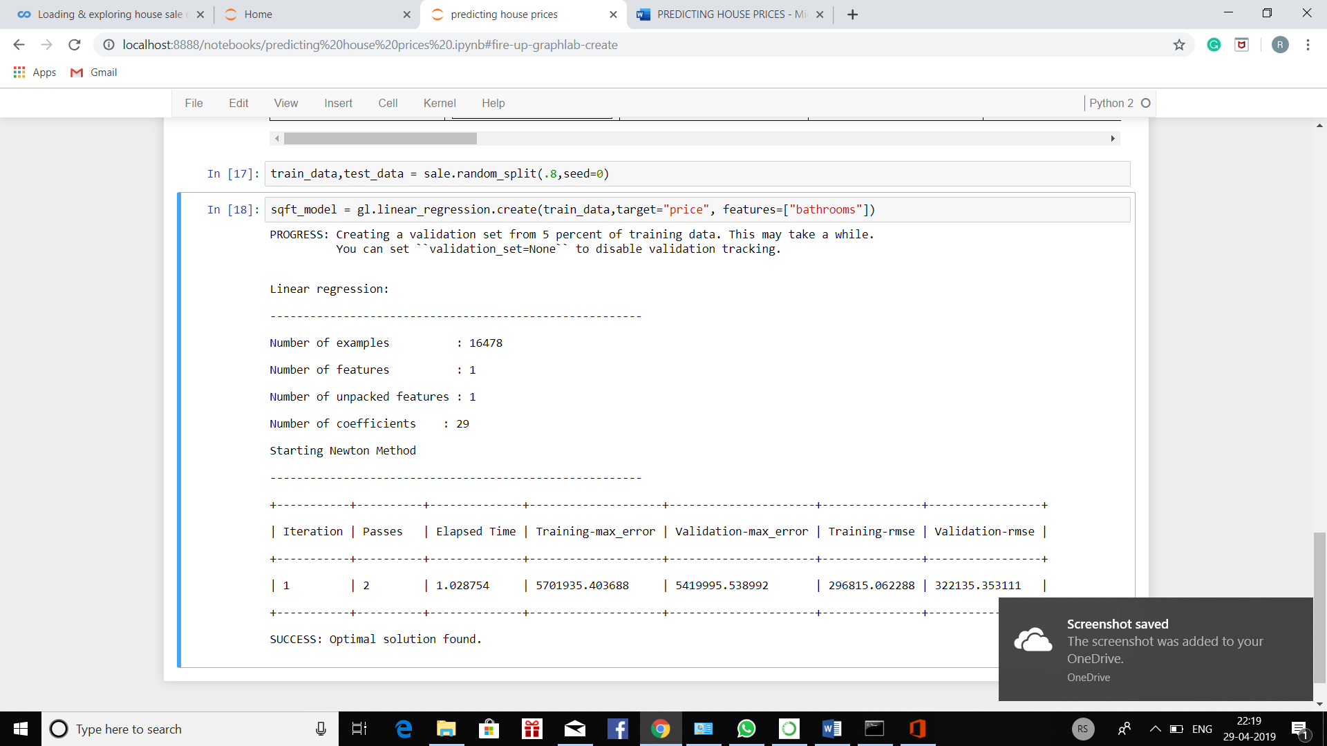

# EXPERIENCE

Through this project, I learn how to do work on ipynb how to implement my ideas in code, and learn something new about the ML what things can ML do.